S3 Bucket And Load Balancer

Task : Create a S3 bucket, with no public access and upload files to the bucket & view the logs for the uploaded files. Launch two ec2-instances and connect it to a application load balancer, where the output traffic from the server must be an load balancer IP address

Create a S3 bucket, with no public access

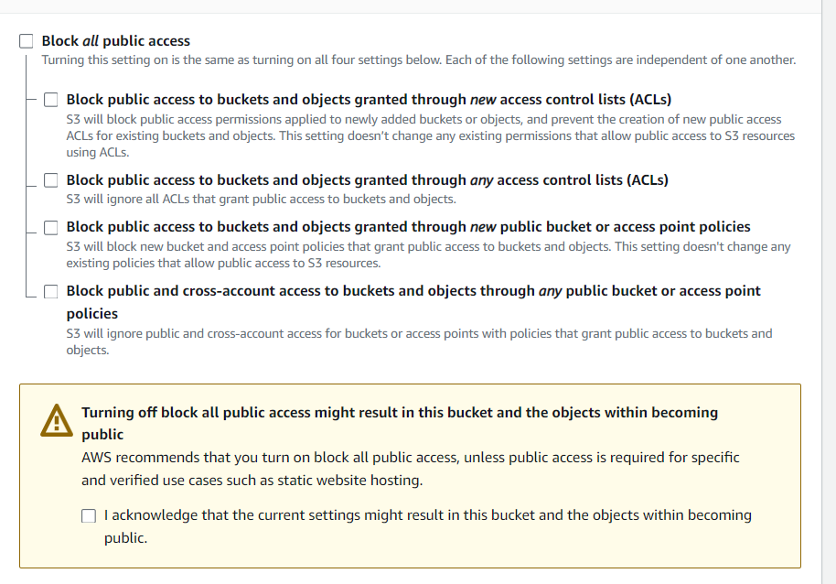

upload files to the bucket

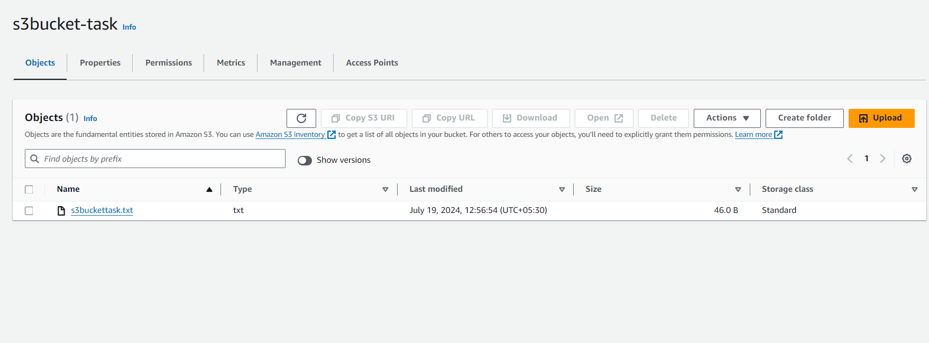

Added target to another bucket

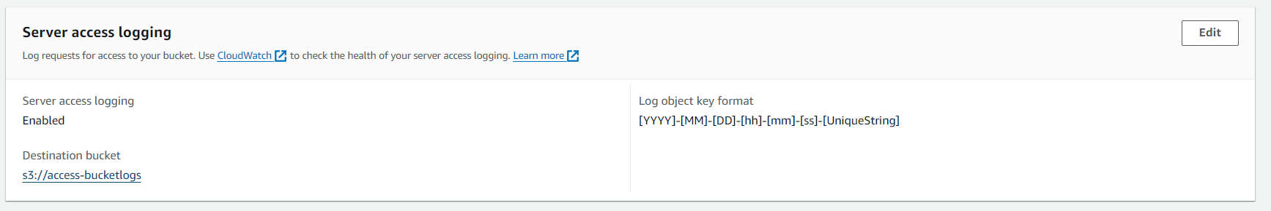

view the logs for the uploaded files

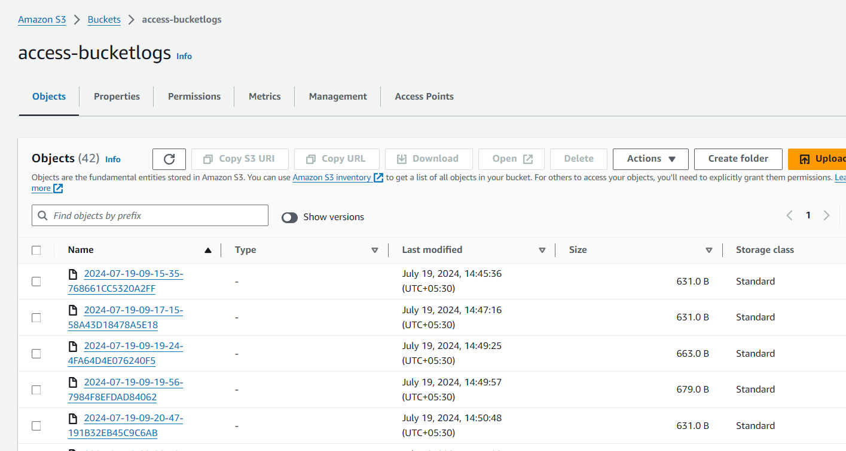

Launch two ec2-instances with webserver



When I access public address of Instance 1 it will show like this like wise same script is ine instance 2

Instance 1



Instance 2

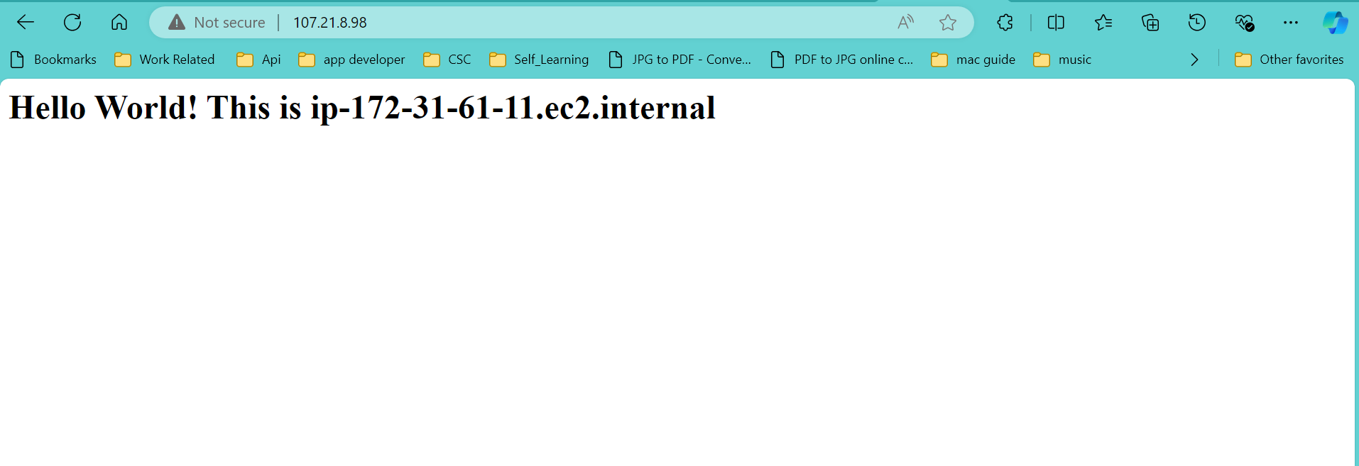

Target grp

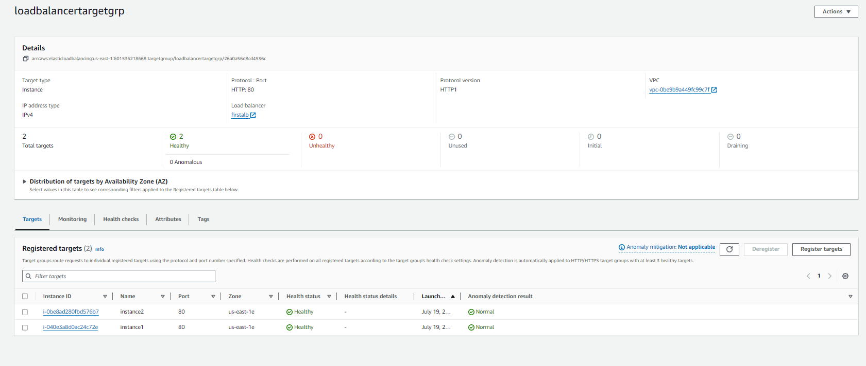

Load balancer

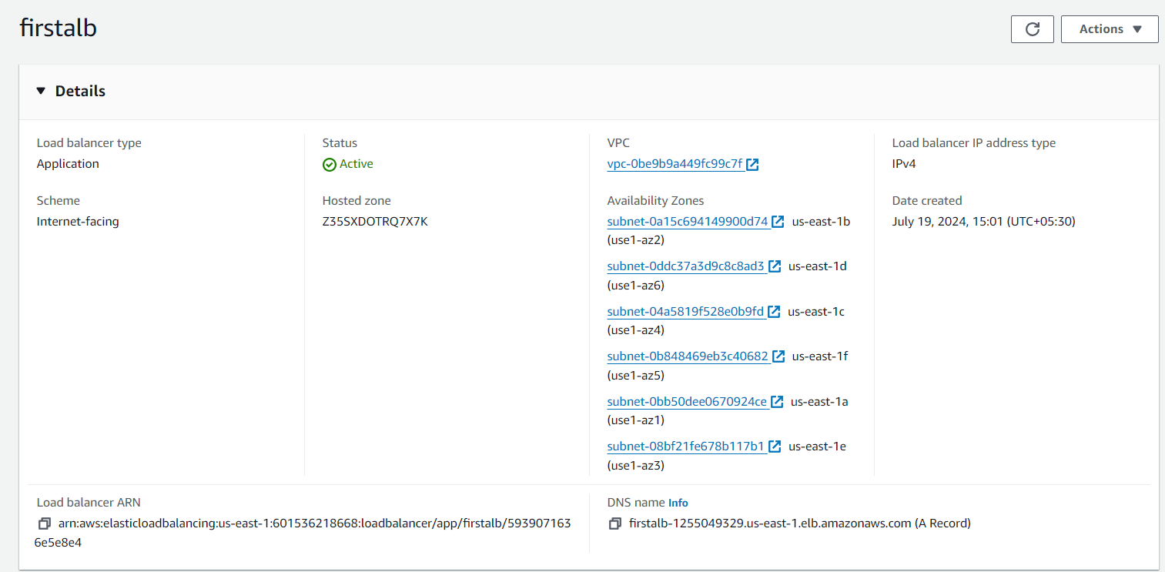

When I try to access dns of load balancer able to see application served by one of the EC2 instance connected.

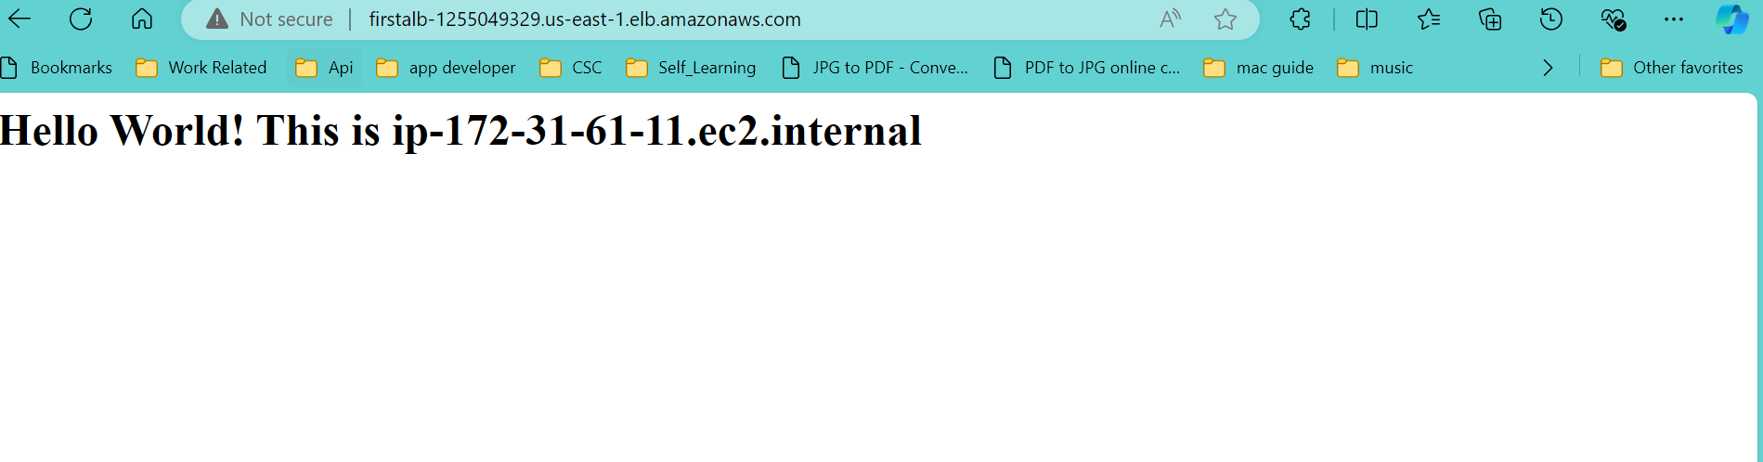

Refresh

